Introduction to the game
You (and your colleagues) are representing a country. Your current baseline carbon dioxide (CO₂) emissions can be seen in the emission table sheet provided separately.
As a part of international negotiation is has been agreed upon that global emissions must decrease, and that some countries have to accept greater responsibility to meet these reductions in CO₂ emissions.
A tradable permit scheme has been agreed in which your county will be given emission permits equal to the target emission for each round respectively (see emission table sheet)
The trading scheme means you can buy a number of permits from other countries at a price in US$ per permit (such that you are entitled to pollute an additional amount equal to the number of permits) or you can sell a number of permits to other countries (such that you are entitled to emit carbon dioxide according to your new amount).
Anyone failing to comply with emissions permits will be fined US$ 200 million per 1 million tonnes over your permitted amount.
With this agreement in mind and the knowledge that you have recently been elected, you are trying to do ‘what is best for the country’.
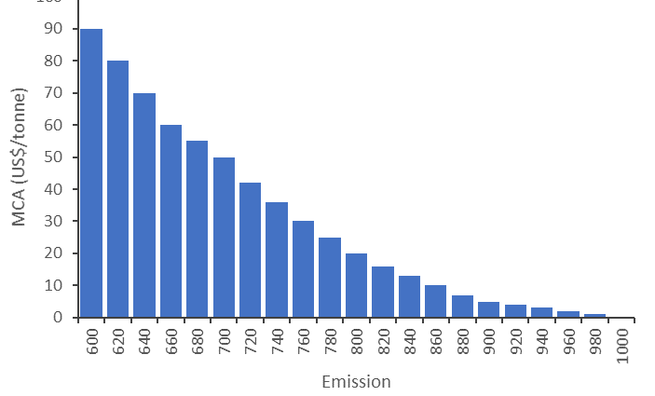
Figure 1. Example graph showing marginal cost of abatement.

Your objective
Your objective is to buy or sell emissions permits with other countries in an attempt to keep the costs of reducing emissions as low as possible.
At the end of each year, we will assess your actual total costs of reducing emissions (based on the emissions reduced, the costs of reducing these emissions, the earnings from selling permits and the costs of buying permits) relative to your initial total costs of abatement (represented in Figure 2).
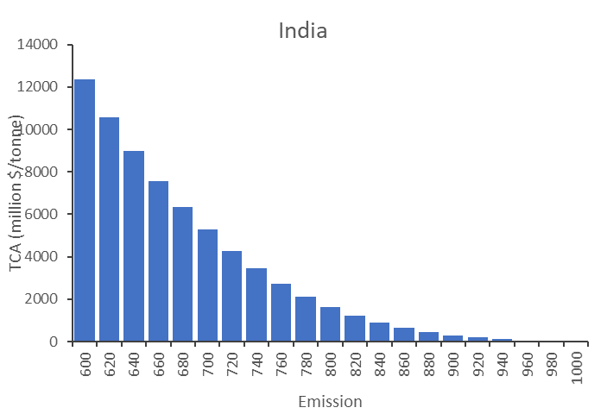
Figure 2. Example graph showing total cost of abatement.

Trading
- To start the game, and to find information about prices of emission permits, an auction will take place, where permits will be allocated to the three highest bidders. Please write on a note how much your country is willing to pay per permit (USD/tonne). The three highest bidders will receive 2% more emission permits paying bid price.
- The total costs of abatement will be written in a logbook (supervisor will do this).
- In subsequent rounds, there will be no auction, just trading.
- You have approximately 15-20 minutes, to agree trades with other countries.
- You can agree as many sales or buys as you want, provided you have permits available to sell.
- When a trade has been agreed, the two countries need to write in the logbook the quantity of permits and the price per permit traded, and the countries involved (supervisor will do this).
- The total cost of abatement, according to your new or unchanged permit level (based on the emissions reduced, the cost of reducing these emissions, the earnings from selling permits and the costs of buying permits) will be calculated by the instructor.
- After each round results will be discussed in class.

